**Assignment 2**

1.Create a class called "Car" that has the following properties: make, model, year, color, and price. Include a constructor and getter and setter methods for each property.

<https://codeshare.io/vwjmBn>

2.Create a class called "Student" that has the following properties: name, age, gender, grade, and GPA. Include a constructor and getter and setter methods for each property.

<https://codeshare.io/78m9NL>

3.Create a class called "Circle" that has the following properties: radius, diameter, and area. Include a constructor and methods to calculate the diameter and area of the circle.

<https://codeshare.io/N3pJz9>

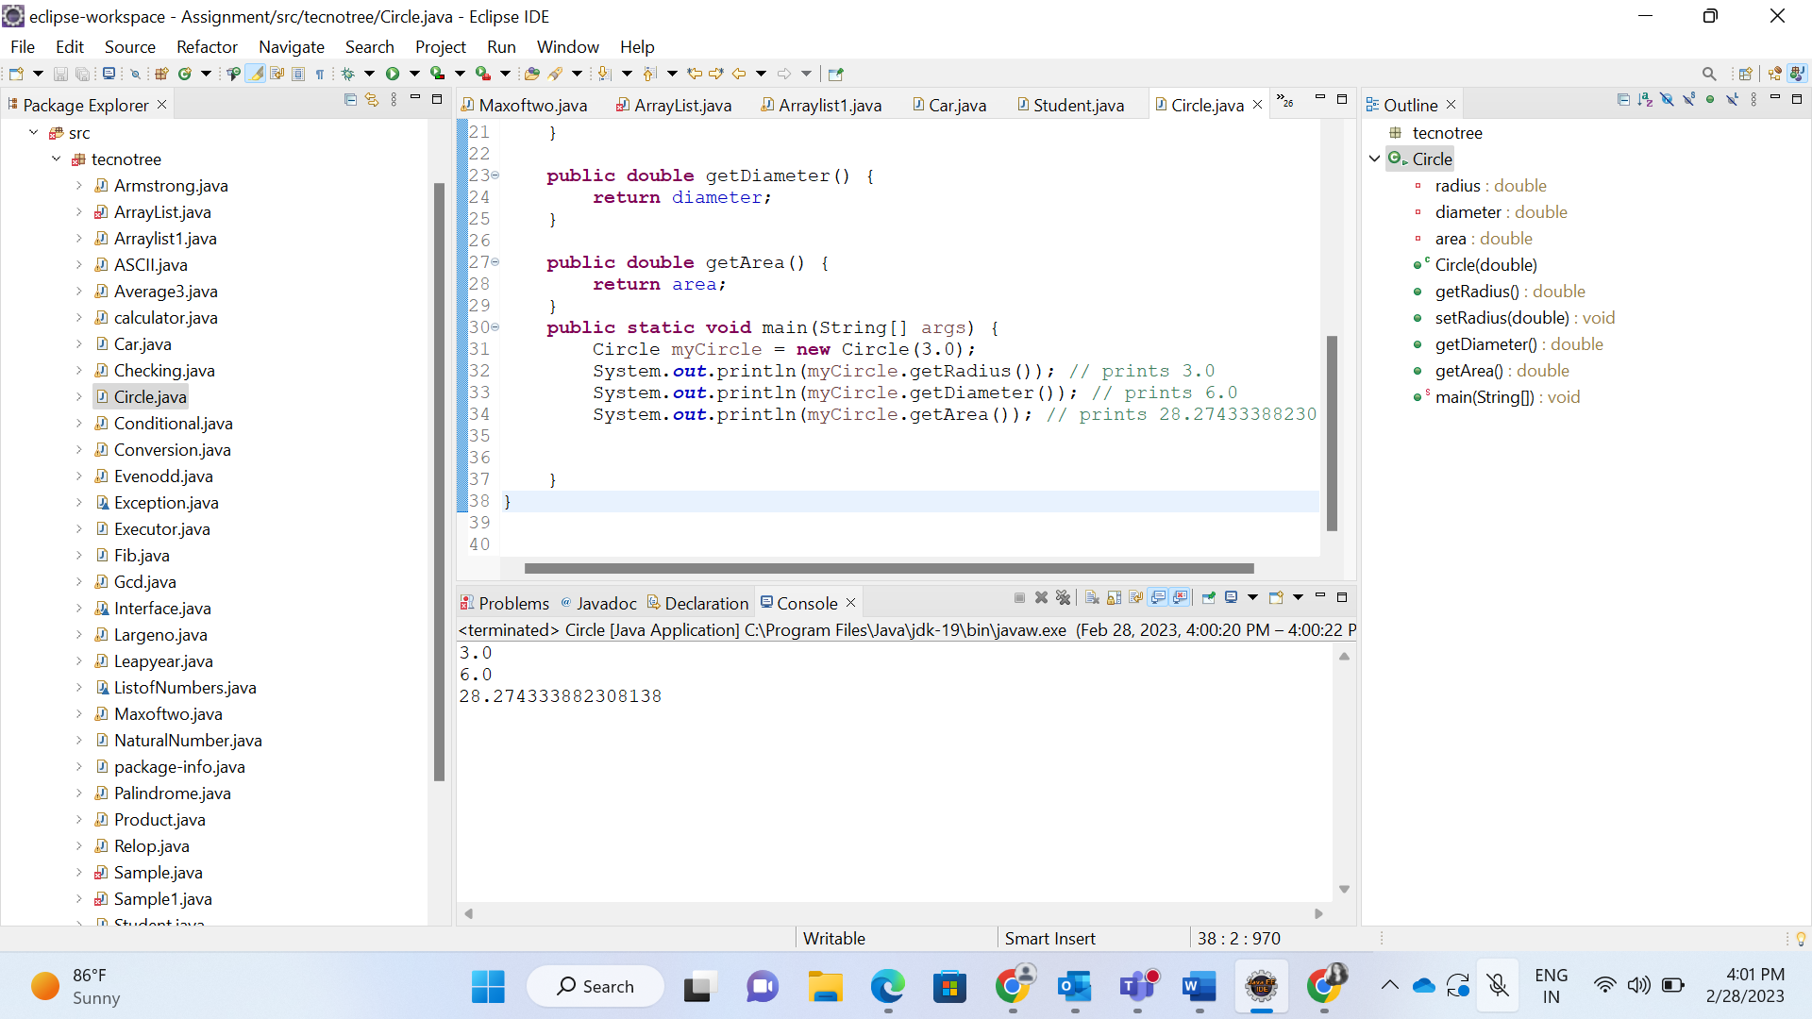

4.Create a class called "Rectangle" that has the following properties: length, width, and area. Include a constructor and a method to calculate the area of the rectangle.

<https://codeshare.io/LwEbde>

5.Create a class called "BankAccount" that has the following properties: account number, account balance, account holder name, and account type. Include a constructor and methods to deposit and withdraw money from the account.

<https://codeshare.io/dwQNXg>

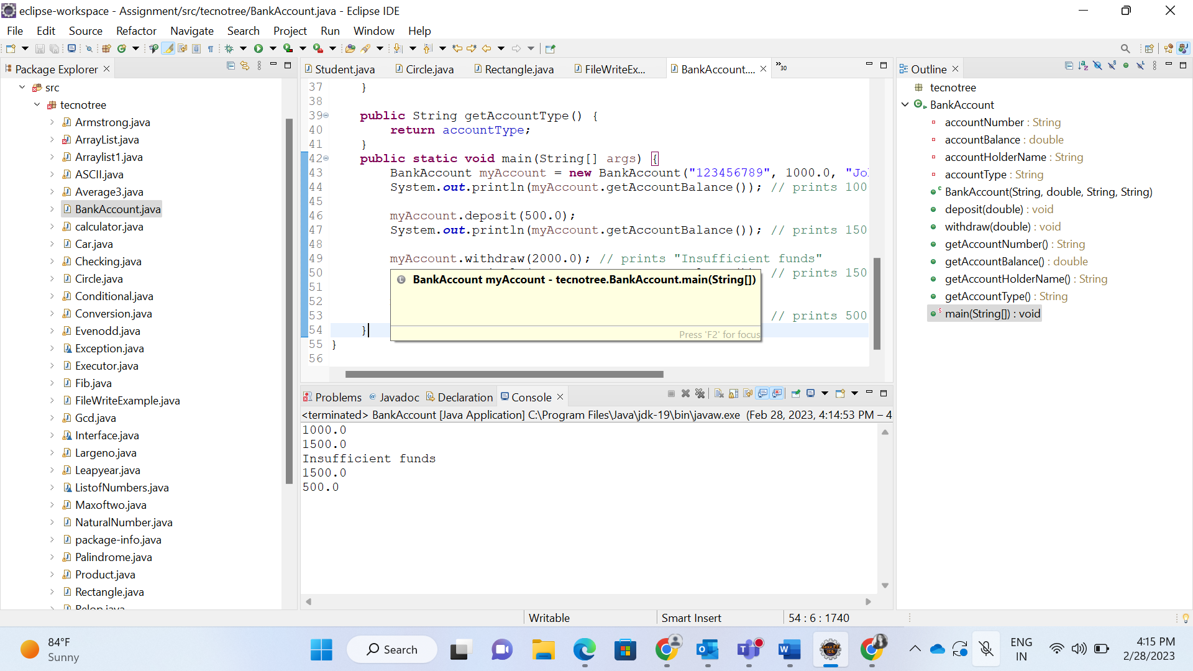

6.Create a class called "Person" that has the following properties: name, age, address, phone number, and email address. Include a constructor and getter and setter methods for each property.

<https://codeshare.io/EBEwrw>

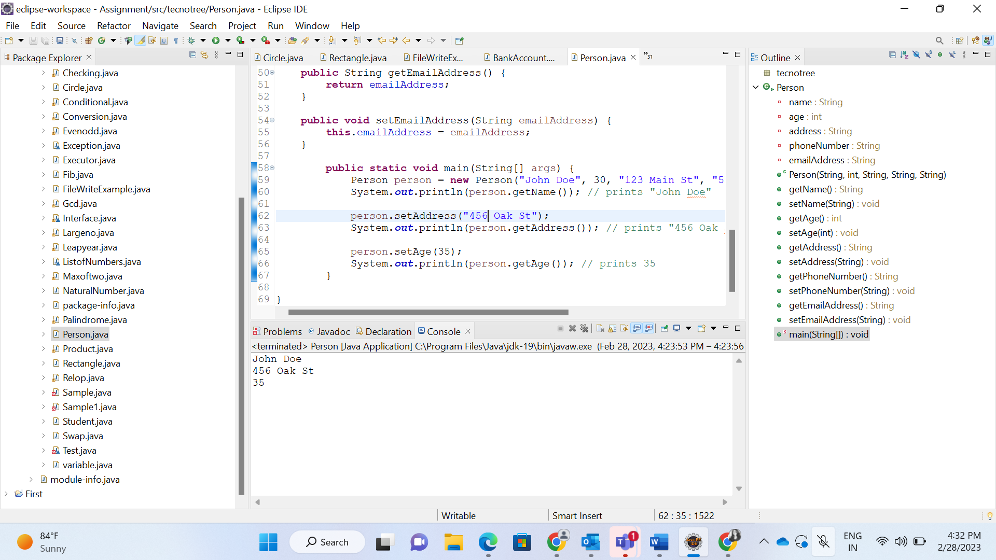

7.Create a class called "Animal" that has the following properties: name, species, age, and weight. Include a constructor and getter and setter methods for each property.

<https://codeshare.io/3AbqDB>

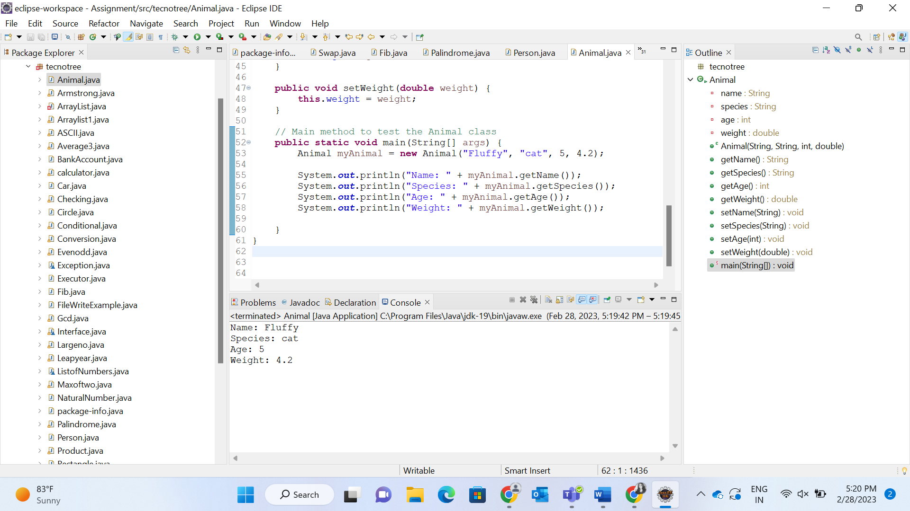

8.Create a class called "Triangle" that has the following properties: base, height, and area. Include a constructor and a method to calculate the area of the triangle.

<https://codeshare.io/bvORQA>

9.Create a class called "Employee" that has the following properties: name, employee ID, department, job title, and salary. Include a constructor and getter and setter methods for each property.

<https://codeshare.io/xv4Y7M>

10.Create a class called "Address" that has the following properties: street, city, state, zip code, and country. Include a constructor and getter and setter methods for each property.

<https://codeshare.io/6pkLdO>

